**SRI SIDDHARTHA DENTAL COLLEGE**

**STAFF AND STUDENT WELFARE COMMITTEE**

**Yoga and wellness**

Health is not a mere absence of disease. It is a dynamic expression of life in terms of how joyful, loving and enthusiastic you are – Sri Sri Ravi Shankar.

Dental profession is a very demanding both mentally and physically. In practice poor posture of dentist leads to back, neck, shoulder pain, rotator cuff injuries, herniated discs and arthritis. Body, mind and spirit are like a tripod, even if one aspect is not functioning properly, our life will not be balanced and that will lead to ill health. Yoga is that link which creates harmony by aligning all the three components (body, mind & soul) into one.

Yoga is an integral part of our life style. So simply change in life style by incorporating yoga, benefits dentists. Practicing yoga as a daily routine offers a better way to overcome any physical and mental stress associated with dental practice.

**SRI SIDDHARTHA DENTAL COLLEGE**

**STAFF AND STUDENT WELFARE COMMITTEE**

**Name of the capability enhancement and skill development scheme: Yoga and wellness**

**Year of implementation: 2019**

**Number of students enrolled:**

**Name of the agencies involved with contact details: Dr Rangegowda, Urologist. 9886982791**

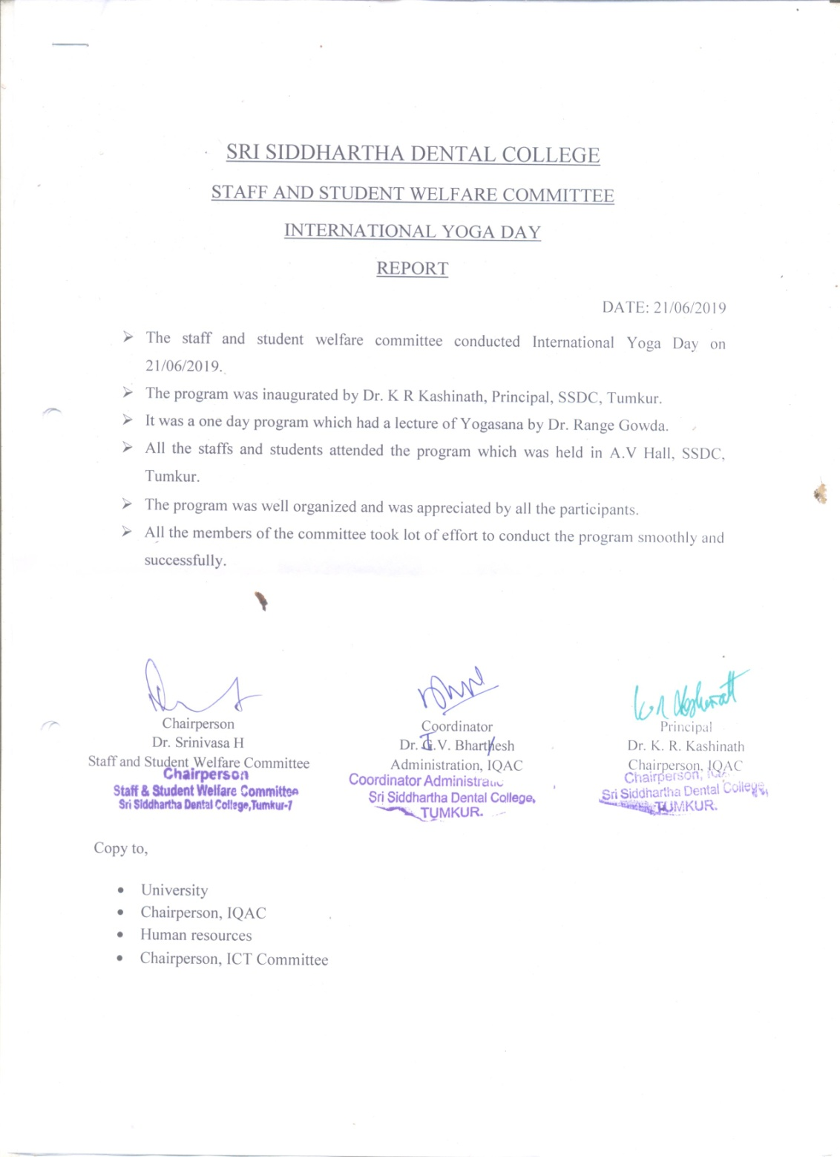

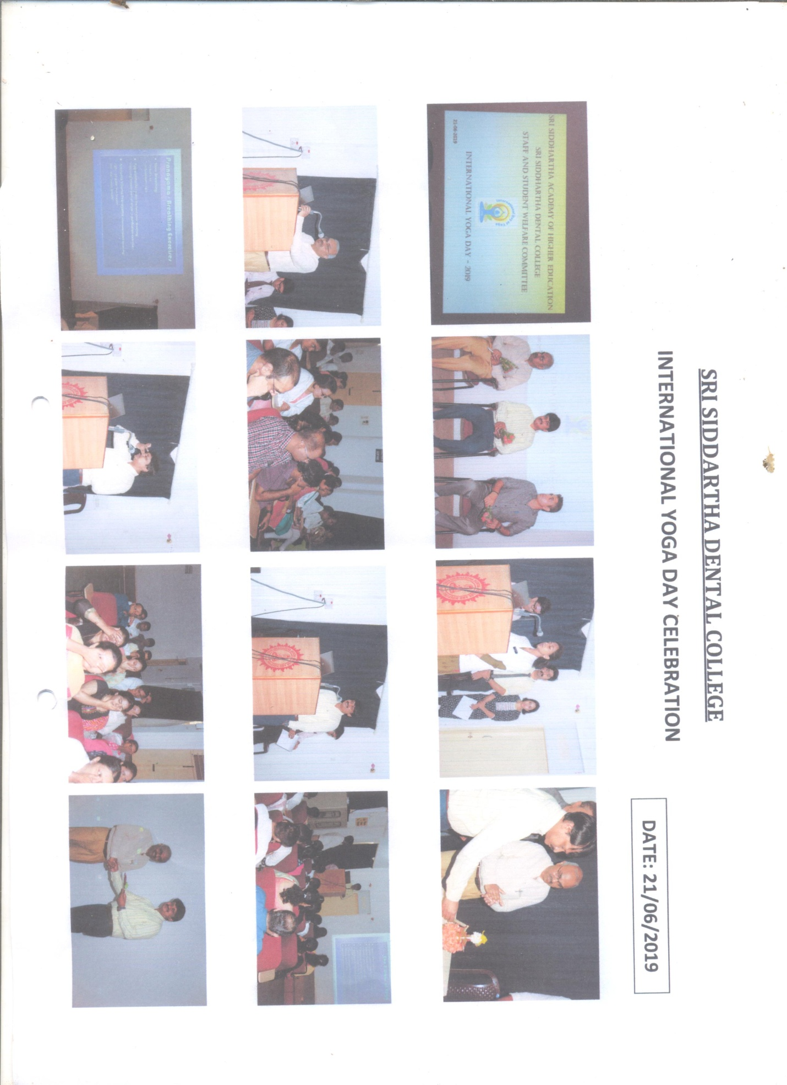

**SRI SIDDHARTHA DENTAL COLLEGE**

**STAFF AND STUDENT WELFARE COMMITTEE**

**Name of the capability enhancement and skill development scheme: Yoga and wellness**

**Year of implementation: 2018**

**Number of students enrolled:**

**Name of the agencies involved with contact details: Staff & Students of Ashwini Ayurvedic college, Tumkur.**

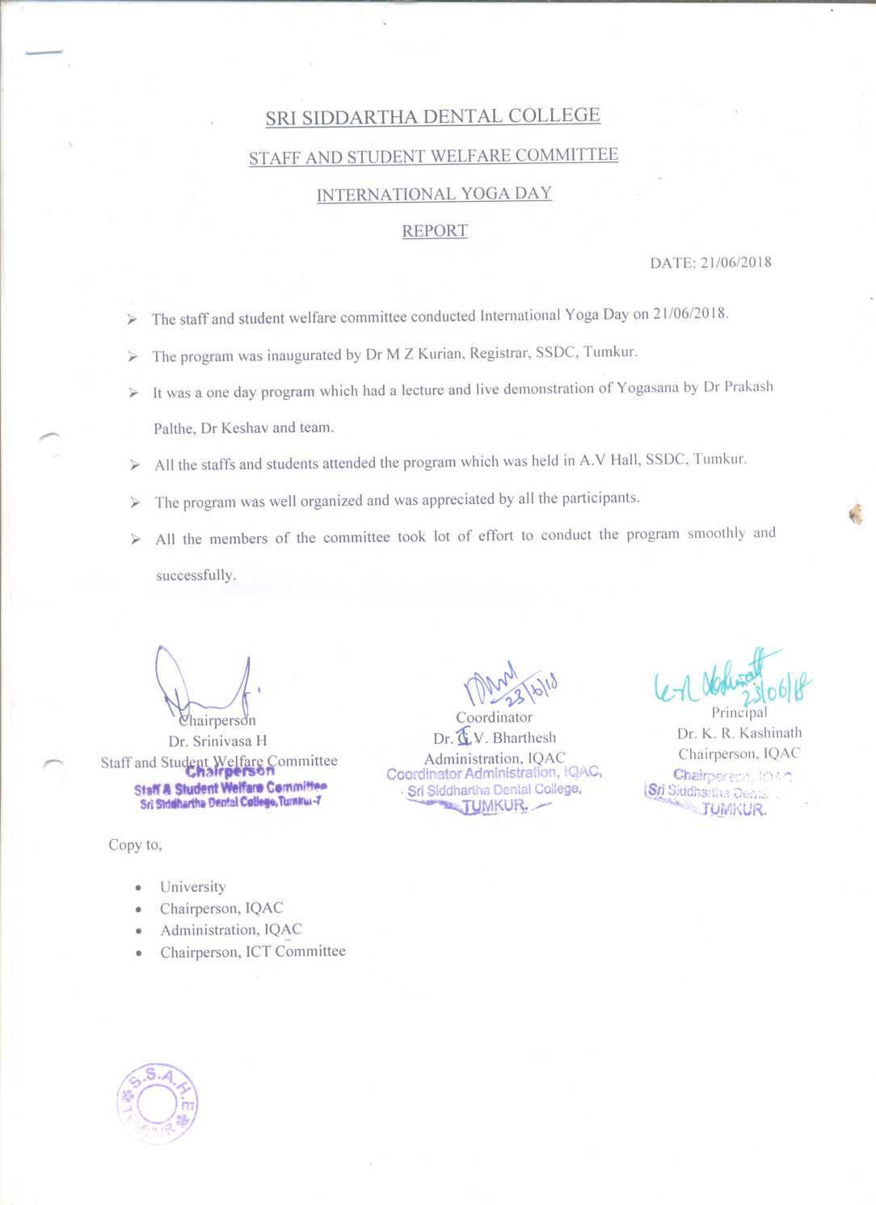

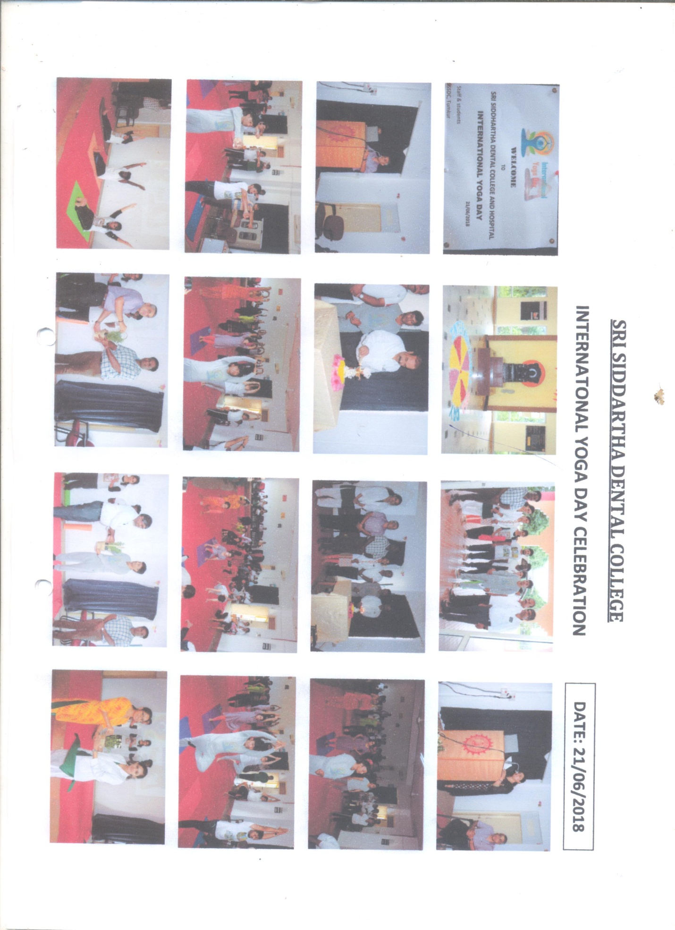

**SRI SIDDHARTHA DENTAL COLLEGE**

**STAFF AND STUDENT WELFARE COMMITTEE**

**Name of the capability enhancement and skill development scheme: Yoga and wellness**

**Year of implementation: 2016**

**Number of students enrolled:**

**Name of the agencies involved with contact details: Sri G.V.V. Shastriji, Yoga teacher & naturopathy exponent & Sri Vasudevachar, Yoga teacher. Tumkur.**



